A

PROJECT REPORT

ON

WIDE-BAND SEMI-CIRCULAR PARASITIC MICROSTRIP PATCH ANTENNA

Submitted in partial fulfillment of the requirements.

For the degree of

BACHELOR OF TECHNOLOGY

in

Electronics & Communication Engineering

Submitted by

ABHISHEK CHAUHAN (1901330310007)

RITIKA SHUKLA (1901330310124)

SHIVANI KUMARI (1901330310143)

PRAVEENKUMAR OMPRAKASH SINGH (19013303150)

Under the Supervision of

Dr V.K PANDEY (Assistant Professor

, ECE)

Noida Institute of Engineering & Technology, Greater Noida (UP), India

 

Dr. A.P.J. Abdul Kalam Technical University, Lucknow (UP), India

March-2023

**DECLARATION**

We hereby declare that this submission is our own work and that, to the best of my knowledge and belief, it contains no material previously published or written by another person nor material which to a substantial extent has been accepted for the award of any other degree of the university or other institute of higher learning, except where due acknowledgement has been in the text.

Signature:

Name:

Roll No.:

Date:

Signature:

Name:

Roll No.:

Date:

Signature:

Name:

Roll No.:

Date:

Signature:

Name:

Roll No.:

Date:

**CERTIFICATE**

This is to certify that the project entitled “DESIGN AND SIMULATION OF MICROSRIP PATCH ANTENNA ARRAY FOR RFID SYSTEM” submitted by Chirag Rastogi (1901330310048), Chandan Kumar (1901330310046), Anishay Kumar(1901330310020), Tushar Sirohi (1901330310061), in the partial fulfillment of the requirements for award of Bachelor of Technology in Electronics and Communication Engineering from Dr. A.P.J. Abdul Kalam Technical University, U.P., Lucknow under my supervision. The project embodies result of original work and studies carried out by the student’s their self and the contents of the project do not form the basis for the award of any other degree to the candidate or to anybody else from this or any other University/Institution.

Dr. Prasanna Kumar Singh

Assistant Professor,ECE

NIET, Greater Noida

**ABSTRACT**

Microstrip patch antennas offer a low profile and small footprint advantages, but limited operating bandwidth. Substantial research focuses on broadband techniques. This paper presents the design, simulation, fabrication, and characterization of a 30% bandwidth microstrip patch antenna that incorporates multiple broadband techniques while minimizing footprint area. Methods include patch shape, dielectric thickness, and coupling slot optimization, with the inset-fed technique.

The design Of radio-frequency identification ( RFID) antenna is urgent and critical since they are a crucial and integrated component of the RFID system. The evolution of RFID antennas may be seen from both a theoretical and a practical perspective.

At 2.5 GHz resonance frequency, the design of a rectangular microstrip patch antenna is presented in this study. A 50-microstrip line supplies the antenna. It is built on a substrate with a thickness of 1.6 mm. and the substrate of type RT/duroid 5880 which dielectric constant is 2.2 mm.

Our antenna was first configured as a single patch antenna, and after assessing the results for the antenna as S11 plot, input impedance, gain, directivity, and voltage standing wave ratio (VSWR), then we changed the antenna design to a 2\*1 linear antenna array to improve the results.

**ACKNOWLEDGEMENT**

In the absence of mother, the birth of a child is not possible and in the absence of teacher the right path of knowledge is impossible. This project is by far the most significant accomplishment in our life and it would be impossible without people who supported us and believed us.

We would like to extend my gratitude and my sincere thanks to my honorable, esteemed guide , Dr.Prasanna Kumar Singh,Assistant Professor,Department of Electronics and Communication Engineering, NIET, Greater Noida for their immeasurable guidance and valuable time that he/she devoted for project. We sincerely thank for their exemplary guidance and encouragement. His trust and support inspired me in the most important moments of making right decisions and we are glad to work with him.

We would also like to give very special thanks to our HOD Sir Dr. Pavan Kumar Shukla (Professor). Also, we would also like to give thanks to our project coordinator , Dr. Prasanna Kumar Singh (and my teachers for their support, help and encouragement during this work.

We would like to thank all my friends for all the thoughtful and mind stimulating discussions we had, which prompted us to think beyond the obvious.

We have enjoyed their companionship so much during my stay at NIET, Greater Noida. We would like to thank all those who made my stay in NIET, Greater Noida an unforgettable and rewarding experience.

A boat held to its moorings will see the floods pass by; but detached of its moorings, may not survive the flood. The support of all the members of our family (specially our parents, our sisters and brothers) motivated us to work even while facing the blues. We dedicate this work to them.

Chirag Rastogi (1901330310048)

Chandan Kumar (1901330310046)

Anishay Kumar (1901330310020)

Tushar Sirohi (1901330310061)

**TABLE OF CONTENTS**

**Page No.**

Declaration ii

Certificate iii

Abstract iv

Acknowledgements v

Table of Contents vi-vii

List of Tables viii

List of Figures ix

Abbreviations x

List of Symbols xi

**CHAPTER 1: INTRODUCTION 1-10**

1.1 Antenna 3

1.2 Motivation with Problem Formulation 4

1.3 Objectives 8

1.4 Structure of Project Report 9

**CHAPTER 2: LITERATURE SURVEY 11-14**

**CHAPTER 3: FUNDAMENTALS OF ANTENNA 15-39**

3.1 Basics of antenna 15

3.1.1 Radiation Pattern 15

3.1.1.1 Omni-Directional Antenna 16

3.1.1.2 Directional Antenna 16

3.1.1.3 Isotropic Antenna 16

3.1.2 Field Regions 16

3.1.3 Directivity 16

3.1.4 Gain 17

3.1.5 Antenna Polarization 18

3.1.6 Antenna Bandwidth 18

3.1.7 Return Loss (RL) 19

3.1.8 Efficiency 20

3.2 Microstrip Patch Antenna (MPA) 21

3.2.1 Classification of Patch Antenna 22

3.2.2 Substrate 23

3.2.2.1 FR-4 or (FR4) 23

3.2.2.2 RO4003 24

3.2.2.3 Taconic TLY 24

3.2.2.4 RT Duroid 25

3.2.3 Fringing Effect 25

3.2.4 Advantages of MPA 26

3.2.5 Disadvantages of MPA 26

3.2.6 Feeding Techniques 26

3.2.6.1 Coaxial Probe Feed 27

3.2.6.2 Microstrip Line Feed 27

3.2.6.3 Aperture Coupled Feed 28

3.2.6.4 Proximity Coupling Feed 28

3.2.7 MPA with Wide Bandwidth 29

3.2.8 Methods of analysis 31-37

3.2.8.1Transmission Line Model 38-39

**CHAPTER 4: RESULTS AND DISCUSSIONS 40-59**

4.1 Design of Microstrip Patch Antenna Array for RFID Applications 40

4.1.1 Introduction

4.1.2 Proposed Antenna Design

4.1.3 Results and Discussions

4.1.3.1 Return Loss/S11 vs. Frequency

4.1.3.2 VSWR vs. Frequency

4.1.3.3 Gain vs. Frequency

4.1.3.4 Directivity vs Frequency

4.1.3.5 Input Impedance vs. Frequency

4.1.3.6 Radiation Pattern

**CHAPTER 5: CONCLUSIONS AND FUTURE SCOPE 60-62**

5.1 Conclusions 60

5.2 Future Scope 62

**APPENDICES 63-66**

**REFERENCES 67-76**

**LIST OF PUBLICATIONS 77**

**CERTIFICATES 78**

**LIST OF TABLES**

|  |  |  |
| --- | --- | --- |
| **Table No.** | **Table Name** | **Page No.** |
| 3.1 | Microwave bands | 38 |
| 4.1 | Relative analysis of simulated and measured result of proposed antenna | 43 |
| 4.2 | Comparative analysis with existing design | 47 |
| 4.3 | Comparison of simulated and fabricated antenna | 58 |
| 4.4 | Comparative analysis with existing designs | 59 |
| 4.5 | Dimensions | 63 |
| 4.6 | Relative analysis of pretended and deliberate result of proposed antenna | 68 |
| 4.7 | Comparison with existing designs | 68 |
| I | Properties of commonly used substrate materials | 84 |
| II | Comparison of different feeding techniques | 86 |

**LIST OF FIGURES**

|  |  |  |
| --- | --- | --- |
| **Figure No.** | **Figure Name** | **Page No.** |
| 1.1 | Antenna as a radiation device | 3 |
| 1.2 | Development in mobile network generations | 5 |
| 1.3 | Structure of report | 10 |
| 3.1 | Directivity of an antenna | 17 |
| 3.2 | Linear, Elliptical and Circular polarizations | 19 |
| 3.3 | Bandwidth | 20 |
| 3.4 | Simple microstrip patch antenna | 22 |
| 4.1 | Shape of proposed antenna | 40 |
| 4.2 | Top and Bottom prospect of fabricated proposed antenna | 41 |
| 4.3 | Measurements of fabricated proposed antenna | 41 |
| 4.4 | S11 vs. frequency for proposed antenna | 42 |
| 4.5 | VSWR vs. frequency for proposed antenna | 43 |
| 4.6 | Gain vs. frequency for proposed antenna | 44 |
| I | Steps to carry out simulation | 85 |

**ABBREVIATIONS**

|  |  |  |
| --- | --- | --- |
| **Abbreviations** | **Full Form** | **Page No.** |
| HE | Hybrid Electric | 3 |
| LED | Light-Emitting Diode | 5 |
| RFI | Radio Interference | 10 |
| TM | Transverse Magnetic | 17 |
| TE | Transverse Electric | 19 |
|  |  |  |
|  |  |  |
|  |  |  |
|  |  |  |
|  |  |  |
|  |  |  |
|  |  |  |
|  |  |  |
|  |  |  |

**LIST OF SYMBOLS**

|  |  |
| --- | --- |
| G | Gain |
| E | Efficiency |
| D | Directivity |
| λ | Wavelength in free space |
| R | Distance from antenna |
| FH | Upper frequency |
| FL | Lower frequency |
| FC | Centre Frequency or Resonant Frequency |
| m and n | Modes |
| εreff | Effective dielectric constant |
| εr | Relative Permittivity or dielectric constantof substrate |
| μr | Relative Permeability |
| Γ | Reflection coefficient |
| W | Widthof patch |
| L | Lengthof patch |
| h | Thickness or height of substrate |

**CHAPTER-1**

**INTRODUCTION**

**1.1 RFID**

RFID, also known as radio frequency identification, is a advanced technology that is very effective, adaptable, and good for autonomous operations. Barcodes are being replaced by a technology that is expanding. When reading data from labels or RFID tags, radio waves are used. Radio waves are also employed by RFID technology to track, identify, and follow objects, animals, and humans.

In order to operate, an RFID system needs a reader and a transponder (tag). The air serves as the medium for communication between these two parts. All information pertaining to the item that specifically identifies it is contained in the tag that is connected to the identifier element. This antenna can read the data kept in the chip. The reader, which can be either fixed or carried in the hand, is the tool responsible for reading RFID tags that are present in its reading range.

RFID system’s antennas play a crucial function. The overall performance of the system depends on factors including return loss, gain, directivity, and bandwidth.

Firstly, the goal of this project is to develop an array antenna which reads microwave band that will be included into a noting system to recognize moving objects or live beings. In order to build this array antenna, performance requirements in terms of frequency, flexibility, gain, and directivity must be taken into consideration.

Modern supply chain management, inventory monitoring, and asset management systems all depend on radio-frequency identification (RFID) technology. Little electrical devices called RFID tags use radio waves to store data and communicate with an RFID reader. A key element of an RFID system that is in charge of sending and receiving these radio waves is an RFID antenna.

The design of RFID antennas, which come in a variety of sizes and forms, is determined by the particular application and RFID system's operating frequency. Between the RFID reader and the RFID tag, the antenna is in charge of sending and receiving signals. The antenna receives the signal from the RFID reader and delivers it to the tag. The antenna detects the response from the tag and relays it to the reader along with a special identifying number.

An RFID system's effectiveness and efficiency are based on the antenna's performance and design. Gain, efficiency, polarisation, and radiation pattern are used to evaluate an antenna's performance. The gain of an antenna is a measurement of how well it can steer radio waves. Efficiency is the percentage of input power that the antenna actually radiates.

**1.2 Motivation with Problem Formulation**

An investigation into the creation of a rectangular microstrip patch antenna for RFID devices is presented in the abstract. The crucial function of RFID antennas in the effective operation of RFID systems serves as the driving force behind this work. Yet, due to the intricate electromagnetic interactions involved in the operation of the antenna, developing an effective RFID antenna is a difficult undertaking.

The design of a rectangular microstrip patch antenna with a resonance frequency of 2.5 GHz, a frequency frequently utilised in RFID systems, is the issue formulation in this work. A substrate with a 1.6 mm thickness and a 2.2 mm dielectric constant is used to create the antenna.

By analysing the S11 plot, input impedance, gain, directivity, and voltage standing wave ratio (VSWR) of the single patch antenna and then changing the design to a 2\*1 linear antenna array, the primary goal of this study is to improve the antenna's performance. We hope to do this by improving the antenna's performance in terms of radiation efficiency, gain, and directivity, which are essential elements for the efficient operation of RFID devices.

The goal of building an RFID antenna is obvious: to make a part that can interact with RFID tags and readers in an efficient manner. Unfortunately, it is not always easy to construct such an antenna because many different things need to be taken into account to guarantee top performance.

We used a rectangular microstrip patch antenna as our starting point for this study. The performance of the antenna was then assessed using a variety of metrics, including the S11 plot, input impedance, gain, directivity, and VSWR. Our investigation of alternative configurations was prompted by the fact that their first single patch antenna design did not match the desired parameters.

We made the decision to change to a 2\*1 linear antenna array in order to enhance the performance of the antenna. This choice was probably made in light of the fact that antenna arrays can perform better by boosting gain and directivity.

Given the requirement for an RFID antenna that runs at 2.5 GHz, how can we build an antenna that satisfies the acceptable standards for S11 plot, input impedance, gain, directivity, and VSWR? After creating a single patch antenna, we iterated on our design until we arrived at a 2\*1 linear antenna array in an effort to find an answer to our issue.

**1.3 Objectives**

A microstrip patch antenna array for use in an RFID system is what the project "Design and Simulation of Microstrip Patch Antenna Array for RFID System" aims to create and model. The proposed antenna array is designed to enhance the read range, gain, and directivity of the RFID system.

Designing a microstrip patch antenna array that can function in the UHF frequency range of 2.5 GHz is the project's main goal. The proposed antenna array should be able to operate in this frequency band because RFID systems frequently use it.

Increasing the gain of the proposed antenna array is another goal of the project. The read range of the RFID system is directly impacted by the gain of the antenna array. A high gain antenna array will therefore enable greater read ranges and more secure data transfer.

The research also seeks to create a high directivity antenna array. The antenna array's directivity is a measurement of its capacity to concentrate its radiation pattern in a particular plane. The scanning of RFID tags will be more accurate and efficient with a highly directed antenna array.

The project's final goal is to use electromagnetic modelling tools to replicate the suggested antenna array design and examine its performance characteristics. The antenna array's behaviour will be better understood thanks to this simulation, which will also make it possible to optimise the design's performance-enhancing characteristics.

The overall goal of this project is to develop and simulate a microstrip patch antenna array that can enhance the read range, gain, and directivity of an RFID system. The development of high-performance RFID systems can be guided by the proposed antenna array design.

**CHAPTER-2**

**LITERATURE SURVEY**

1. C. A. Balanis, *Antenna theory: Analysis and Design* (3rd edition, John Wiley & Sons, 2013).
2. J. R. James, P. S. Hall and C. Wood, *Microstrip Antenna Theory and Design* (IET, 1981).
3. Kai Da Xu, Han Xu, Yanhui iu, Jianxing Li and Qing Huo Liu, *Microstrip Patch Antennas with Multiple Parasitic Patches and Shorting Vias For Bandwidth Enhacement* (IEEE Access, Volume: 6, P. 11624 – 11633, 2018).
4. Eduardo S. Silveira, Denial C. Nascimento, Alexis F. Tinnoco and Marcus V.P. Pina, *Design of Microstrip Antenna Array with Suppressed Back Lobe*, (Journal of Microwaves, Optoelectronics and Electromagnetic Applications, Vol. 16, No. 2, pp. 460-470, 2017).
5. Nusrat Jahan Shimu, Anis Ahmed, *Design and Performance Analysis of Rectangular Microstrip Patch Antenna at 2.45 GHz* (2016 5th International Conference on Informatics, Electronics and Vision (ICIEV), IEEE).
6. Giang Bach Hoang, Giap Nguyen Van, Linh Ta Phuong, Tuan Anh Vu and Duong Bach Gia, *Research, Design and Fabrication of 2.45 GHz Microstrip Patch Antenna Arrays for Close-Range Wireless Power Transmission Systems* (2016 International Conference on Advanced Technologies for Communications (ATC), IEEE).
7. Hafid TIZIYI, Fatima RIOUCH, Abdelwahed TRIBAK, Abdellah NAJID, *Compact Dual-band Microstrip Antenna for Handheld RFID Reader* (IEEE 2015).
8. A. ELHamraoui, E. Abdelmounim, J. Zbitou, A. Tajmouati, L. EL Abdellaoui, A. Errkik, M. Latrach, *Compact CPW-Fes Dual-Band Uniplanar Antenna for RFID Applications* (2015, IEEE).

[1] An extensive textbook on the fundamentals of antenna theory and design can be found in Antenna Theory: Analysis and Design by C. A. Balanis. The book has been used as a textbook in colleges all over the world and is recognised as one of the most reliable references in the field of antenna engineering.

The third version, released in 2013, updates coverage of conventional antenna ideas and adds additional content on contemporary antenna design and analysis methods. Basic antenna characteristics, radiation patterns, antenna arrays, aperture antennas, reflector antennas, and frequency-selective surfaces are only a few of the many subjects covered in the book.

The book's emphasis on practical design considerations is one of its strong points.

[2] The development of microstrip antenna technology was greatly influenced by the key research article "Microstrip Antenna Theory and Design" by J. R. James, P. S. Hall, and C. Wood. One of the most often used references in the field of antenna engineering, the article was published by the Institute of Electrical Engineers (IEE) in 1981.

The theoretical underpinnings and design methods for microstrip antennas are presented in detail in this study. It addresses a variety of subjects, such as the fundamentals of microstrip antennas, analysis methods, realistic design considerations, and performance traits.

The creation of the cavity model for microstrip antennas was one of the paper's most important contributions.

[3] 2018 saw the publication of the research paper "Microstrip Patch Antennas with Multiple Parasitic Patches and Shorting Vias for Bandwidth Improvement" in IEEE Access. Kai Da Xu, Han Xu, Yanhui Liu, Jianxing Li, and Qing Huo Liu wrote the paper.

In this study, an unique method for increasing the bandwidth of microstrip patch antennas is presented. This method makes use of several parasitic patches and shorting vias. The authors show that the bandwidth of the patch antenna may be greatly extended without reducing its radiation efficiency by carefully arranging parasitic patches and shorting vias all around it.

[4] 2017 saw the publication of the study "Design of Microstrip Antenna Array with Suppressed Back Lobe" in the Journal of Microwaves, Optoelectronics and Electromagnetic Applications. Marcus V.P. Pina, Alexis F. Tinnoco, Denilson C. Nascimento, and Eduardo S. Silveira wrote the paper.

In order to solve a typical issue with antenna array design, the research suggests a novel method for creating microstrip antenna arrays with suppressed back lobes. The authors show that the back lobe can be greatly decreased, resulting in enhanced antenna performance, by carefully choosing the amplitude and phase of the excitation currents in the antenna array elements.

[5] A research paper entitled "Design and Performance Analysis of Rectangular Microstrip Patch Antenna at 2.45 GHz" was presented at the 2016 5th International Conference on Informatics, Electronics, and Vision (ICIEV) and was later made available by IEEE. Anis Ahmed and Nusrat Jahan Shimu wrote the paper.

The investigation of the design and performance evaluation of a rectangular microstrip patch antenna operating at 2.45 GHz is presented in this research. The authors give a thorough design technique for the rectangular patch antenna and talk about the essential ideas behind microstrip patch antennas.

The authors also look into how various antenna factors, such substrate thickness and patch dimensions, affect the performance of the antenna.

[6] An IEEE-published research paper entitled "Research, Design and Fabrication of 2.45 GHz Microstrip Patch Antenna Arrays for Close-Range Wireless Power Transmission Systems" was presented at the 2016 International Conference on Advanced Technologies for Communications (ATC). Giang Bach Hoang, Giap Nguyen Van, Linh Ta Phuong, Tuan Anh Vu, and Duong Bach Gia wrote the study.

The design, manufacture, and performance evaluation of a microstrip patch antenna array for 2.45 GHz close-range wireless power transmission systems are covered in this article. For effective wireless power transmission, the authors suggest a novel method for building a microstrip patch antenna array with high gain and good directivity.

The proposed antenna design has been thoroughly theoretically analysed by the authors.

[7] IEEE released a study titled "Compact Dual-band Microstrip Antenna for Handheld RFID Reader" in 2015. Hafid TIZIYI, Fatima RIOUCH, Abdelwahed TRIBAK, and Abdellah NAJID are the authors of the study.

The design and development of a portable, dual-band microstrip antenna for a handheld RFID reader are discussed in this study. The authors suggest a fresh method for creating a compact antenna with high gain and an omnidirectional radiation pattern for use with RFID readers.

The proposed antenna design is presented in depth theoretically, and the performance of the antenna is examined in relation to several antenna parameters such substrate material, patch size, and feed placement.

[8] A study paper titled "Compact CPW-Fes Dual-Band Uniplanar Antenna for RFID Applications" was released by IEEE in 2015. A. ELHamraoui, E. Abdelmounim, J. Zbitou, A. Tajmouati, L. EL Abdellaoui, A. Errkik, and M. Latrach are the authors of the study.

The design and development of a small, dual-band CPW-Fes uniplanar antenna for RFID (Radio Frequency Identification) applications are discussed in the study. The authors suggest a novel method for creating a dual-band operating antenna, which is necessary for effective RFID systems.

The proposed antenna design is presented in depth theoretically, and the performance of the antenna is examined in relation to several antenna parameters such substrate material, patch size, and feed placement.

**CHAPTER-3**

**FUNDAMENTALS OF ANTENNA**

**3.1 Basics of Antenna**

**3.1.1 Radiation Pattern of Microstrip Patch Antenna**

Due to its small size, low profile, and simplicity of construction, a microstrip patch antenna is a form of antenna that is frequently employed in wireless communication systems. The directional characteristics of the electromagnetic waves emitted by a microstrip patch antenna are referred to as the radiation pattern.

A microstrip patch antenna's main lobe and side lobes can be used to define its radiation pattern. The antenna's main lobe, which is the area in space where it radiates the majority of its power, is normally centred along the boresight, or the axis that runs perpendicular to the antenna's surface. The antenna radiates less energy in the side lobes of space than it does in the main lobe.

A microstrip patch antenna's radiation pattern is shaped by a number of variables, including the antenna's size and shape, the substrate's composition, the placement of the feed point, and the operating frequency. A microstrip patch antenna typically radiates in an E-plane (i.e., a plane parallel to the antenna's surface) and an H-plane (i.e., a plane perpendicular to the antenna's surface) pattern that is broad in the former and narrow in the latter.

A microstrip patch antenna's radiation pattern can be described by a number of factors, including beamwidth, directivity, gain, and polarisation. The angle between the two places on either side of the main lobe where the antenna's power output is half its highest value is known as the beamwidth.

The ratio of the radiation intensity in the direction of greatest radiation to the average radiation intensity across all directions is known as the directivity, and it is a measurement of how well an antenna concentrates its radiation in a certain direction. The ratio of the power radiated by the antenna in a specific direction to the power that would be radiated by an isotropic radiato is known as the gain, and it is used to determine how much the antenna amplifies the signal it receives or transmits.

**3.1.2 Field Regions**

A microstrip patch antenna is a type of antenna that consists of a conducting patch placed on a substrate, separated by a ground plane. When excited with an electromagnetic wave, the patch radiates energy into the surrounding space. The fields in the vicinity of a microstrip patch antenna can be divided into three regions: the near field, the reactive near field, and the far field.

Near Field:

The near field is the region immediately surrounding the patch, where the electric and magnetic fields are not yet fully developed. In this region, the fields are reactive and do not propagate as radiated waves. The near field extends up to a distance of about one wavelength from the patch, and the energy is stored in the electric and magnetic fields.

Reactive Near Field:

The reactive near field is the region beyond the near field where the fields are still reactive but are starting to propagate as radiated waves. In this region, the electric and magnetic fields are not in phase, and the energy is stored in the magnetic field. The reactive near field extends from a distance of one wavelength to about two wavelengths from the patch.

Far Field:

The far field is the region beyond the reactive near field, where the fields are fully developed and propagate as radiated waves. In this region, the electric and magnetic fields are in phase, and the energy is radiated away from the antenna. The far field starts at a distance of about two wavelengths from the patch, and it extends to an infinite distance. The far field is also called the radiation zone, and it is the region where the antenna can be used for communication or other applications.

Understanding these regions is important for the design and optimization of microstrip patch antennas. For example, the near field and reactive near field can cause unwanted coupling between nearby antennas or other electronic components. Therefore, it is important to minimize these fields by properly designing the antenna and its surroundings.

**3.1.3 Directivity**

Directivity is a measure of the concentration of radiated power in a particular direction for an antenna. For a microstrip patch antenna, the directivity depends on the geometry of the patch and the substrate, as well as the frequency of operation. The directivity of a microstrip patch antenna can be determined using the following equation:

D = 4π(𝐴/λ^2)

Where D is the directivity, A is the effective aperture area of the antenna, and λ is the wavelength of the signal.

The effective aperture area of the microstrip patch antenna can be calculated using the following equation:

A = εr \* λ^2 / (4π) \* |E\_max|^2

Where εr is the relative permittivity of the substrate, λ is the wavelength, and E\_max is the maximum electric field at the surface of the patch.

The directivity of a microstrip patch antenna can be increased by increasing the effective aperture area. This can be achieved by increasing the size of the patch or by using a substrate with a higher relative permittivity. However, increasing the size of the patch also increases the complexity of the design and may not be practical for certain applications.

In general, microstrip patch antennas have moderate to high directivity compared to other types of antennas. The directivity of a microstrip patch antenna can range from a few dB to over 10 dB depending on the design parameters and the operating frequency. The directivity can also be affected by the presence of nearby objects, which can cause reflections and diffraction that can alter the radiation pattern of the antenna.

**3.1.4 Gain**

The gain of a microstrip patch antenna depends on various factors such as the substrate material, patch dimensions, feed location, and shape of the patch. Generally, the gain of a microstrip patch antenna can be calculated using the following formula:

G = 4πA/λ²

where G is the antenna gain, A is the effective aperture of the antenna, and λ is the wavelength of the signal in free space.

The effective aperture of a microstrip patch antenna can be calculated using the following formula:

A = (eff \* W \* L) / 2

where eff is the effective dielectric constant of the substrate material, W is the width of the patch, and L is the length of the patch.

Therefore, the gain of a microstrip patch antenna can be increased by using a substrate material with a higher dielectric constant, increasing the width and length of the patch, and optimizing the feed location and shape of the patch.

**3.1.5 Antenna Polarization**

Antenna polarization refers to the orientation of the electromagnetic waves that are emitted by the antenna. Polarization can be vertical, horizontal, circular, or elliptical, and it is usually determined by the physical structure of the antenna.

A microstrip patch antenna is a type of antenna that is commonly used in modern communication systems. It consists of a thin, flat rectangular patch of metal that is mounted on a ground plane. The patch is usually made of copper or some other conductive material, and it is separated from the ground plane by a dielectric substrate.

The polarization of a microstrip patch antenna is determined by the orientation of the patch relative to the ground plane. If the patch is oriented parallel to the ground plane, the antenna will have horizontal polarization. If it is oriented perpendicular to the ground plane, the antenna will have vertical polarization.

Microstrip patch antennas can also be designed to have circular polarization, which is useful for certain applications such as satellite communication. This is achieved by using a patch that is circular or elliptical in shape, and by feeding the antenna with a special type of feed network that introduces a phase difference between the two orthogonal modes of the antenna.

Overall, the polarization of a microstrip patch antenna is an important factor to consider when designing and using the antenna, as it can have a significant impact on the performance and effectiveness of the antenna in a given application.

**3.1.6 Antenna Bandwidth**

Antenna bandwidth refers to the range of frequencies over which the antenna can effectively operate. It is usually specified as the frequency range between the two frequencies at which the antenna's performance has decreased to a certain level, such as half-power (-3 dB) or one-tenth power (-10 dB) of its peak performance.

An antenna's bandwidth is determined by a number of factors, including its physical dimensions, materials, and design. Generally, larger antennas tend to have wider bandwidths than smaller antennas, although this is not always the case. In addition, certain types of antennas, such as horn antennas and broadband dipole antennas, are specifically designed to have wide bandwidths.

Antenna bandwidth is an important consideration in many applications, especially in communication systems where a wide range of frequencies may be used. A narrowband antenna may not be able to effectively receive or transmit signals over a wide frequency range, while a wideband antenna may be able to operate over a broader range of frequencies but may not be as efficient or effective at any one particular frequency.

It's also important to note that the bandwidth of an antenna can be affected by its surroundings. The presence of nearby objects, such as buildings or trees, can cause reflections, diffraction, and other effects that can alter the antenna's performance and reduce its effective bandwidth.

**3.1.7 Return Loss (RL)**

Return loss (RL) is a measure of the amount of power that is reflected back from an antenna due to impedance mismatches between the antenna and the transmission line or system to which it is connected. It is expressed in decibels (dB) and is defined as the ratio of the power of the reflected signal to the power of the incident signal.

In the case of a microstrip patch antenna, the RL is an important performance parameter that is closely related to the antenna's impedance matching. When the impedance of the antenna is well-matched to the impedance of the transmission line or system, the RL will be low, indicating that most of the power is being radiated by the antenna and not reflected back.

A high RL indicates that a significant amount of the power is being reflected back, which can lead to reduced performance and efficiency of the antenna. Therefore, it is desirable to design microstrip patch antennas with low RL values over the desired frequency range.

There are several methods for measuring the RL of a microstrip patch antenna, including using a network analyzer or a vector network analyzer. In addition, simulation tools such as electromagnetic field solvers can also be used to predict the RL of a microstrip patch antenna before it is fabricated.

Overall, the RL of a microstrip patch antenna is an important parameter that should be carefully considered during the design and testing of the antenna to ensure optimal performance and efficiency.

**3.1.8 Efficiency**

Efficiency is a measure of how much of the input power is actually radiated by the antenna, rather than being lost or dissipated in the antenna structure or surrounding environment. In the case of a microstrip patch antenna, efficiency is an important performance parameter that is closely related to the antenna's design and construction.

The efficiency of a microstrip patch antenna is affected by several factors, including the quality of the substrate material, the thickness of the substrate, the size and shape of the patch, and the feed mechanism used to excite the antenna. A well-designed microstrip patch antenna can have an efficiency of 80-90% or higher, meaning that the vast majority of the input power is radiated as electromagnetic waves.

One of the main factors that affects the efficiency of a microstrip patch antenna is the dielectric substrate. The substrate material and thickness determine the dielectric constant and loss tangent of the substrate, which in turn affect the amount of power that is absorbed by the substrate and lost as heat. Higher-quality substrates with lower loss tangents and higher dielectric constants can help to increase the efficiency of the antenna.

Another important factor that affects the efficiency of a microstrip patch antenna is the feed mechanism. The feed should be designed to match the impedance of the antenna as closely as possible to minimize the amount of power that is reflected back to the source. In addition, the feed should be positioned in a way that minimizes the amount of power that is lost to the substrate or surrounding environment.

Overall, designing a microstrip patch antenna with high efficiency requires careful consideration of a range of factors, including substrate quality, patch size and shape, and feed mechanism design. By optimizing these factors, it is possible to create microstrip patch antennas with high efficiency that are well-suited for a wide range of applications in communication, radar, and sensing systems.

**3.2 Microstrip Patch Antenna (MPA)**

**3.2.1 Classification of Patch Antenna**

Patch antennas can be classified based on several different criteria, including the shape of the patch, the type of feeding mechanism, the polarization of the antenna, and the frequency band of operation. Here are some of the most common classifications of patch antennas:

Shape: The shape of the patch can be rectangular, circular, triangular, or other geometric shapes. Rectangular patches are the most common, but circular patches can offer better circular polarization characteristics.

Feeding Mechanism: Patch antennas can be fed using various mechanisms, including microstrip line, coaxial probe, aperture coupling, and proximity coupling. Microstrip line feeding is the most common, while coaxial probe feeding is commonly used for circularly polarized antennas.

Polarization: Patch antennas can be linearly polarized or circularly polarized, depending on the orientation of the electric field. Linear polarization is more common and can be either vertical or horizontal, while circular polarization is used for applications where the orientation of the signal may change.

Frequency Band: Patch antennas can be classified based on the frequency band of operation, such as L-band, S-band, C-band, X-band, and Ku-band. Each frequency band has different advantages and disadvantages, and the choice of frequency band depends on the application requirements.

Stacked or Multilayer: Patch antennas can also be classified based on their construction. Stacked or multilayer patch antennas consist of multiple layers of patches and are used to increase the bandwidth and radiation efficiency of the antenna.

These are some of the most common classifications of patch antennas, but there are many other factors that can be used to classify these antennas, such as shape of the ground plane, thickness of the substrate, and the number of patches used in the antenna design.

**3.2.2 Substrate**

The substrate is a non-conductive material that is used as the base or foundation of the antenna structure. The substrate is typically a thin sheet of dielectric material that is sandwiched between the patch element and the ground plane.

The choice of substrate material and thickness is an important consideration in the design of a microstrip patch antenna, as it can affect several important performance parameters, including the resonant frequency, bandwidth, radiation pattern, and efficiency of the antenna.

Some common materials used for microstrip patch antenna substrates include fiberglass-reinforced epoxy (FR4), Rogers RT/Duroid, and Teflon (PTFE). The dielectric constant and loss tangent of the substrate material determine the resonant frequency and bandwidth of the antenna. A higher dielectric constant results in a lower resonant frequency and narrower bandwidth, while a lower loss tangent results in higher antenna efficiency.

The thickness of the substrate also affects the performance of the antenna. A thicker substrate can lead to a lower resonant frequency and wider bandwidth, but it can also increase the surface wave propagation on the substrate, leading to higher losses and reduced efficiency.

Overall, the choice of substrate material and thickness should be carefully considered in the design of a microstrip patch antenna, as it can have a significant impact on the performance of the antenna. By selecting the right substrate material and thickness, it is possible to optimize the performance of the antenna for a given application.

**3.2.2.1 FR-4 or (FR4)**

FR-4 or (FR4) refers to a type of fiberglass-reinforced epoxy laminate that is commonly used as a substrate material in printed circuit boards (PCBs) and microstrip patch antennas. FR-4 is a standardized material that is widely available and relatively inexpensive, making it a popular choice for a wide range of electronic applications.

FR-4 has a relatively high dielectric constant (typically around 4.4), which makes it suitable for use in microstrip patch antennas operating at relatively low frequencies, such as those in the 900 MHz to 5.8 GHz range. However, the high dielectric constant can also result in a narrow bandwidth and lower radiation efficiency compared to other substrate materials.

FR-4 also has a relatively high loss tangent, which can lead to higher losses in the antenna structure and reduced efficiency. However, the loss tangent can be reduced by using lower-loss FR-4 formulations or by adding special fillers to the material.

Despite its limitations, FR-4 remains a popular choice for microstrip patch antenna substrates due to its availability, affordability, and ease of processing. Many commercial microstrip patch antennas are designed using FR-4 substrates, and it is often used as a benchmark material for comparing the performance of other substrate materials.

**3.2.2.2 RO4003**

RO4003 is a high-performance substrate material that is commonly used in the design of microstrip patch antennas and other high-frequency electronic circuits. It is a member of the RO family of materials from Rogers Corporation, which includes several different types of high-frequency laminates.

RO4003 is a ceramic-filled, woven-glass-reinforced PTFE composite material that has a low dielectric constant (around 3.38) and a low loss tangent (around 0.0027). This makes it well-suited for use in microstrip patch antennas and other high-frequency applications where low loss and high performance are critical.

The low dielectric constant of RO4003 allows for wider bandwidth and higher radiation efficiency compared to substrates with higher dielectric constants, such as FR-4. The low loss tangent of RO4003 also helps to minimize losses in the antenna structure, resulting in higher efficiency.

RO4003 is available in various thicknesses ranging from 0.005" to 0.125", allowing for the design of antennas and circuits with a wide range of dimensions and performance characteristics. It is also compatible with standard PCB fabrication processes, making it easy to use in commercial production.

**3.2.2.3 Taconic TLY**

Taconic TLY is a type of substrate material that is commonly used in the design of microstrip patch antennas and other high-frequency electronic circuits. It is a member of the TLY family of materials from Taconic Advanced Dielectric Division, which includes several different types of high-frequency laminates.

Taconic TLY is a ceramic-filled, woven-glass-reinforced PTFE composite material that has a low dielectric constant (around 2.45) and a low loss tangent (around 0.0015). This makes it well-suited for use in microstrip patch antennas and other high-frequency applications where low loss and high performance are critical.

The low dielectric constant of Taconic TLY allows for wider bandwidth and higher radiation efficiency compared to substrates with higher dielectric constants, such as FR-4. The low loss tangent of Taconic TLY also helps to minimize losses in the antenna structure, resulting in higher efficiency.

Taconic TLY is available in various thicknesses ranging from 0.005" to 0.125", allowing for the design of antennas and circuits with a wide range of dimensions and performance characteristics. It is also compatible with standard PCB fabrication processes, making it easy to use in commercial production.

Overall, Taconic TLY is a high-performance substrate material that is well-suited for microstrip patch antenna design and other high-frequency electronic applications that require low loss and high performance.

**3.2.2.4 RT Duroid**

RT Duroid is a family of high-performance substrate materials that are commonly used in the design of microstrip patch antennas and other high-frequency electronic circuits. The RT Duroid family is manufactured by Rogers Corporation, a global leader in high-performance specialty materials.

RT Duroid materials are ceramic-filled, woven-glass-reinforced PTFE composite materials that offer a range of dielectric constants (typically from 2.2 to 10.2) and loss tangents (typically from 0.0009 to 0.0035). This allows designers to select a material that is optimized for their specific application requirements, such as bandwidth, radiation efficiency, and frequency range.

RT Duroid materials are known for their high mechanical strength and dimensional stability, which make them well-suited for use in high-performance applications that require high reliability and precision. They are also compatible with standard PCB fabrication processes, making them easy to use in commercial production.

RT Duroid materials are available in various thicknesses, allowing for the design of antennas and circuits with a wide range of dimensions and performance characteristics. They are commonly used in applications such as satellite communications, radar systems, and wireless networks, where high performance and reliability are critical.

**3.2.3 Fringing Effect**

The fringing effect in microstrip patch antennas refers to the electric field lines that extend beyond the edge of the patch. These fringing fields can affect the radiation pattern and impedance of the antenna.

In a microstrip patch antenna, a metal patch is placed on a substrate with a ground plane on the other side. The patch is typically smaller than the wavelength of the operating frequency, so the fringing fields play an important role in the overall behavior of the antenna.

The fringing effect causes the electric field lines to bend and extend beyond the edge of the patch. This can create additional radiation lobes, which can distort the radiation pattern and reduce the efficiency of the antenna.

To mitigate the effects of fringing, designers may use various techniques such as increasing the width of the ground plane, adding a parasitic patch, or using a thicker substrate. These techniques can help to improve the impedance matching and radiation efficiency of the antenna.

**3.2.4 Advantages of MPA**

Microstrip patch antennas have several advantages that make them popular in a wide range of applications. Here are some of the key advantages:

Low profile: Microstrip patch antennas have a very low profile, making them ideal for applications where space is limited. They can be easily integrated into small devices and systems.

Lightweight: Microstrip patch antennas are lightweight and can be easily fabricated using printed circuit board (PCB) technology. This makes them a cost-effective solution for many applications.

Wideband operation: Microstrip patch antennas can operate over a wide frequency range. By adjusting the shape and size of the patch and the substrate, the antenna can be designed to operate at multiple frequencies.

Directional radiation pattern: Microstrip patch antennas can be designed to have a directional radiation pattern, which makes them suitable for applications where focused radiation is required.

Easy integration with other circuits: Microstrip patch antennas can be easily integrated with other circuits on the same substrate, such as amplifiers and filters. This makes them a flexible solution for many applications.

Polarization flexibility: Microstrip patch antennas can be designed to radiate in different polarization modes, including linear, circular, and elliptical polarizations. This makes them suitable for a wide range of applications, including satellite communications, GPS, and wireless networks.

Overall, the low profile, lightweight, and wideband operation of microstrip patch antennas make them a popular choice for many applications, including wireless communications, radar, and satellite systems.

**3.2.5 Disadvantages of MPA**

While microstrip patch antennas have many advantages, they also have some limitations and disadvantages, including:

Low efficiency: Microstrip patch antennas have lower radiation efficiency compared to other types of antennas, such as dipole and horn antennas. This is due to losses in the substrate, ground plane, and feedline.

Narrow bandwidth: While microstrip patch antennas can be designed to operate over a wide frequency range, their bandwidth is often limited compared to other types of antennas. This can be a disadvantage in applications where a wider bandwidth is required.

Sensitivity to the substrate and ground plane: The performance of microstrip patch antennas is highly dependent on the properties of the substrate and ground plane. Any variations in these properties can affect the impedance matching and radiation pattern of the antenna.

Limited power handling: Microstrip patch antennas have a low power handling capability compared to other types of antennas, due to their small size and low efficiency.

Cross-polarization: Microstrip patch antennas can suffer from cross-polarization, where the antenna radiates energy in unintended polarizations. This can be a disadvantage in applications where the polarization of the received signal is important.

Overall, while microstrip patch antennas have many advantages, their lower efficiency, narrow bandwidth, and sensitivity to substrate and ground plane properties can be disadvantages in certain applications.

**3.2.6 Feeding Techniques**

Feeding techniques are used to provide power to a microstrip patch antenna and to excite its radiating element. Here are some commonly used feeding techniques for microstrip patch antennas:

Coaxial feed: In this technique, a coaxial cable is connected to the patch through a hole in the ground plane. The center conductor of the coaxial cable is connected to the patch, while the outer conductor is connected to the ground plane.

Microstrip feed: In this technique, a microstrip transmission line is used to feed the patch. The transmission line is typically placed along the edge of the patch and is coupled to the patch through a small gap or aperture.

Proximity feed: In this technique, a small loop or patch is placed close to the main patch, and power is coupled between the two elements through a small gap or aperture. This technique is often used to achieve dual-band or circular polarization operation.

Aperture-coupled feed: In this technique, the patch is fed through an aperture in the ground plane, which is coupled to a microstrip transmission line on the opposite side of the ground plane. This technique is often used to achieve higher radiation efficiency and wider bandwidth.

Inverted-F feed: In this technique, a shorting pin is used to connect the patch to the ground plane, and the feed point is located along a short-circuited stub that extends from the patch. This technique is often used to achieve low-profile and compact antennas.

Proximate-coupled feed: In this technique, a small patch or loop is placed directly on top of the main patch, and power is coupled between the two elements through a small gap or aperture. This technique is often used to achieve wideband operation and higher radiation efficiency.

**3.2.7 Antenna Arrays: Design**

Antenna arrays are collections of individual antennas that work together to achieve a desired performance. They are used in various applications such as communication systems, radar systems, and satellite systems. The design of antenna arrays involves several steps:

Determine the application requirements: The first step in designing an antenna array is to determine the application requirements. This includes the desired frequency range, bandwidth, gain, beamwidth, and polarization.

Select antenna elements: The next step is to select the antenna elements that will be used in the array. The choice of antenna elements depends on the application requirements and the desired performance.

Determine the array geometry: The array geometry determines the spacing between the antenna elements and the orientation of the elements. The spacing between the elements is determined by the desired beamwidth and the operating frequency. The orientation of the elements is determined by the polarization of the signal.

Determine the feed network: The feed network connects the individual antenna elements to the transmitter or receiver. The feed network can be designed to provide different beamforming capabilities, such as beam steering and beam shaping.

Simulate the array performance: Once the array geometry and feed network have been determined, the performance of the array can be simulated using electromagnetic simulation software. The simulation results can be used to optimize the array design and ensure that the array meets the application requirements.

Fabricate and test the array: After the array design has been optimized, the array can be fabricated and tested. The testing can be done in an anechoic chamber or in the field, and the results can be compared to the simulated results to validate the array design.

Overall, the design of an antenna array is a complex process that requires expertise in electromagnetics, antenna design, and signal processing.

**3.2.8 Antenna Arrays: Beam Forming**

Beamforming is a signal processing technique used in antenna arrays to enhance the directivity and gain of the array. Beamforming involves manipulating the signals received or transmitted by the individual antennas in the array to create a focused beam in a specific direction.

There are two types of beamforming: analog beamforming and digital beamforming.

Analog beamforming is performed in the analog domain, using phase shifters or time delay units to adjust the phase and amplitude of the signals received or transmitted by each antenna element. Analog beamforming is relatively simple and low-cost, but it is limited in its ability to adapt to changing conditions.

Digital beamforming, on the other hand, is performed in the digital domain, using digital signal processing techniques to adjust the phase and amplitude of the signals received or transmitted by each antenna element. Digital beamforming is more complex and expensive than analog beamforming, but it offers greater flexibility and adaptability.

Beamforming can be used for a variety of applications, such as wireless communication systems, radar systems, and sonar systems. In a communication system, beamforming can be used to improve signal quality and reduce interference. In a radar or sonar system, beamforming can be used to improve target detection and localization.

Overall, beamforming is an important technique for improving the performance of antenna arrays, and it is a key area of research in the field of electromagnetics and signal processing.

**3.2.9 Antenna Arrays: Application**

Antenna arrays have a wide range of applications in various fields, including communication systems, radar systems, satellite systems, and wireless sensor networks. Here are some of the specific applications of antenna arrays:

Wireless Communication Systems: Antenna arrays are used in wireless communication systems, such as cellular networks, Wi-Fi networks, and satellite communication systems. They can improve signal quality, increase range and capacity, and reduce interference.

Radar Systems: Antenna arrays are used in radar systems to detect and track objects in the air, on the ground, or at sea. They can improve target detection and localization, increase range and resolution, and reduce clutter.

Satellite Systems: Antenna arrays are used in satellite systems to transmit and receive signals between the satellite and ground stations. They can improve signal quality, increase coverage, and reduce interference.

Wireless Sensor Networks: Antenna arrays are used in wireless sensor networks to improve the accuracy and reliability of sensor data. They can reduce noise and interference, and improve the range and resolution of the sensors.

Smart Antennas: Smart antennas are antenna arrays with digital signal processing capabilities. They can adapt the antenna beam direction and shape in real-time to improve signal quality, increase range and capacity, and reduce interference.

Radio Astronomy: Antenna arrays are used in radio astronomy to capture and analyze radio waves from space. They can improve the sensitivity and resolution of radio telescopes, and enable the study of distant objects and phenomena in the universe.

Overall, antenna arrays have a wide range of applications in various fields, and their versatility and flexibility make them an important tool for improving the performance of communication and sensing systems.

**3.4. Microstrip Antennas: Design**

**3.4.1 Antenna Arrays: Design**

Microstrip antennas are a type of planar antenna that is widely used in various applications due to their low profile, low cost, and ease of integration with other electronic components. Here are some general steps for designing a microstrip antenna:

Determine the operating frequency range: The first step in designing a microstrip antenna is to determine the operating frequency range. This can be done by considering the application requirements and the available frequency spectrum.

Select the substrate material: The substrate material is a key factor in the performance of a microstrip antenna. The choice of substrate material depends on the desired frequency range, the dielectric constant, and the thickness of the substrate.

Determine the antenna dimensions: The antenna dimensions, including the length, width, and height, are determined by the operating frequency range and the substrate material. The length of the patch antenna is typically half of the wavelength of the operating frequency in the substrate material.

Determine the feeding mechanism: The feeding mechanism is used to connect the microstrip antenna to the transmission line. The most common feeding mechanisms are microstrip line feed and coaxial feed. The choice of feeding mechanism depends on the desired impedance, bandwidth, and radiation pattern.

Simulate and optimize the antenna design: Once the antenna dimensions and feeding mechanism have been determined, the antenna design can be simulated and optimized using electromagnetic simulation software. The simulation results can be used to optimize the antenna design and ensure that the antenna meets the desired specifications.

Fabricate and test the antenna: After the antenna design has been optimized, the antenna can be fabricated using standard PCB fabrication techniques. The antenna can then be tested in an anechoic chamber or in the field, and the results can be compared to the simulated results to validate the antenna design.

Overall, the design of a microstrip antenna requires expertise in antenna theory, electromagnetic simulation, and PCB fabrication techniques. However, the design process can be simplified with the use of commercial electromagnetic simulation software and standard PCB fabrication techniques.

**3.4.2 Antenna Arrays: Analysis**

The analysis of microstrip antennas involves the calculation of various parameters related to antenna performance, such as radiation pattern, gain, impedance matching, bandwidth, and efficiency. Here are some common analysis techniques used for microstrip antennas:

Moment Method Analysis: The moment method is a numerical technique used to calculate the electromagnetic fields and currents on the microstrip antenna. It is based on solving the integral equations that describe the electric and magnetic fields on the antenna surface.

Finite Element Method Analysis: The finite element method is a numerical technique used to solve partial differential equations that describe the electromagnetic fields on the antenna. It is used to calculate the electric and magnetic fields and currents on the microstrip antenna.

Method of Moments Analysis: The method of moments is a numerical technique used to solve the integral equations that describe the electric and magnetic fields on the antenna surface. It is based on approximating the current distribution on the antenna surface using a set of basis functions.

Network Analysis: Network analysis is a technique used to analyze the impedance matching and bandwidth of microstrip antennas. It involves calculating the S-parameters of the antenna and using them to determine the reflection coefficient, impedance bandwidth, and input impedance of the antenna.

Radiation Pattern Analysis: Radiation pattern analysis is used to determine the directionality and shape of the radiation pattern of the microstrip antenna. It involves measuring the electric field strength at various angles around the antenna and plotting the results on a polar graph.

Gain Analysis: Gain analysis is used to determine the gain of the microstrip antenna, which is a measure of the antenna's ability to radiate energy in a particular direction. It involves comparing the antenna's radiation pattern to that of an ideal isotropic radiator.

Overall, the analysis of microstrip antennas is a complex process that requires expertise in antenna theory, electromagnetic simulation, and signal processing. The analysis techniques used depend on the specific parameters that need to be calculated and the available resources and tools.

**3.4.3 Antenna Arrays: Applications**

Microstrip antennas have a wide range of applications in various fields due to their low profile, light weight, and ease of integration with other electronic components. Here are some specific applications of microstrip antennas:

Mobile and Wireless Communications: Microstrip antennas are widely used in mobile and wireless communication systems, such as cellular phones, Wi-Fi networks, and Bluetooth devices. They can be integrated with other electronic components, such as power amplifiers and filters, to form compact and efficient communication systems.

Satellite and Space Communications: Microstrip antennas are used in satellite and space communication systems due to their light weight and low profile. They can be used for satellite-to-satellite and satellite-to-ground communication links, and can be designed to operate in different frequency bands.

RFID Systems: Microstrip antennas are used in radio frequency identification (RFID) systems for tracking and identifying objects. They can be integrated with RFID tags to form compact and low-cost tracking systems.

Automotive Radar: Microstrip antennas are used in automotive radar systems for collision avoidance and adaptive cruise control. They can be integrated with other electronic components, such as radar sensors and processors, to form efficient and reliable radar systems.

Medical Applications: Microstrip antennas are used in medical applications, such as wireless medical implants and body-worn sensors. They can be designed to operate at low frequencies and to be compatible with human tissue.

**3.4.4 Antenna Matching Techniques: Baluns**

A balun, short for "balanced-unbalanced," is a device used to match a balanced transmission line, such as a twisted-pair cable or a ladder line, to an unbalanced transmission line, such as a coaxial cable. The purpose of a balun is to convert the balanced signal to an unbalanced signal, or vice versa, depending on the application.

There are two main types of baluns:

Current baluns: These are designed to match a balanced load to an unbalanced transmission line. They work by converting the current flowing on the balanced load into a voltage on the unbalanced transmission line.

Voltage baluns: These are designed to match an unbalanced load to a balanced transmission line. They work by converting the voltage on the unbalanced load into a current on the balanced transmission line.

Baluns can be used in a variety of applications, including radio frequency (RF) circuits, power amplifiers, and antenna systems. In antenna systems, baluns are often used to match a balanced antenna, such as a dipole, to an unbalanced coaxial cable.

Baluns come in many different forms, including:

Transformer baluns: These use a transformer to convert the impedance of the balanced load to the impedance of the unbalanced transmission line.

Transmission line baluns: These use a section of transmission line to convert the impedance of the balanced load to the impedance of the unbalanced transmission line.

Hybrid baluns: These use a combination of transformer and transmission line techniques to provide a balanced-to-unbalanced conversion.

In summary, baluns are an important technique used in antenna matching to convert between balanced and unbalanced transmission lines. They can be used in a variety of applications and come in many different forms.

**3.4.5 Antenna Propagation: Reflection**

Reflection is one of the phenomena that affect the propagation of electromagnetic waves, including radio waves that are used for wireless communication through antennas. Reflection occurs when an electromagnetic wave encounters an obstacle or a boundary that causes it to bounce back.

In the case of antennas, reflection can occur when the waves encounter a surface, such as a wall or a metallic object, that reflects them back towards the transmitting antenna. This reflected wave can interfere with the original wave, causing constructive or destructive interference, which can either increase or decrease the signal strength at the receiver.

Reflection can be minimized through careful antenna placement and design, such as using antennas with directional radiation patterns, which focus the transmitted signal in a specific direction and minimize the amount of signal that is reflected back. Additionally, using materials with low reflection coefficients, such as foam or fiberglass, can also help to reduce the amount of reflection.

However, in some cases, reflection can be useful for improving signal strength and coverage. For example, in indoor wireless communication systems, reflection from walls and other surfaces can help to extend the coverage area by reflecting and redirecting the signal towards areas that would otherwise be difficult to reach.

**3.4.6 Antenna Arrays: Diffraction**

A diffraction microstrip patch antenna is a type of antenna used in wireless communication systems. It is a variant of the microstrip patch antenna, which is a flat antenna that is popular due to its low profile and ease of integration with other electronic components.

The diffraction microstrip patch antenna consists of a thin metallic patch placed on top of a grounded substrate. The patch is typically rectangular or circular in shape, and its dimensions are carefully chosen to resonate at a particular frequency. The ground plane beneath the substrate provides a stable reference plane for the antenna and helps to reduce unwanted radiation.

In the case of the diffraction microstrip patch antenna, a diffraction grating is etched on the top surface of the substrate beneath the patch. The diffraction grating is a periodic structure of equally spaced slots or grooves that act as a reflector for the radiation emitted by the antenna. The grating diffracts the radiation at angles other than the broadside direction, which enhances the directivity and gain of the antenna.

The diffraction microstrip patch antenna is commonly used in applications where high directivity and gain are required, such as satellite communication systems, radar systems, and wireless backhaul systems.

**3.4.7 Antenna Arrays: Refraction**

A microstrip patch antenna is a type of directional antenna that is commonly used in wireless communication systems. It is a flat rectangular or circular patch that is usually printed on a dielectric substrate, which is then placed over a ground plane. The patch and ground plane are separated by a small air gap or a dielectric layer.

Refraction microstrip patch antennas are a type of microstrip patch antenna that use a dielectric material with a varying refractive index to control the propagation of the electromagnetic wave. The dielectric material is usually placed on top of the patch, which modifies the effective length and width of the patch. By varying the refractive index of the dielectric material, the propagation of the electromagnetic wave can be controlled, which results in improved antenna performance, such as increased gain and bandwidth.

There are several advantages to using refraction microstrip patch antennas, including:

Increased gain: Refraction microstrip patch antennas can achieve higher gain compared to traditional microstrip patch antennas due to the modified effective length and width of the patch.

Wide bandwidth: By using a dielectric material with a varying refractive index, the bandwidth of the antenna can be increased, which is important for communication systems that require a large bandwidth.

Low profile: Refraction microstrip patch antennas are typically low profile, which makes them well-suited for use in applications where space is limited.

However, there are also some challenges associated with refraction microstrip patch antennas, such as:

Fabrication complexity: Fabrication of refraction microstrip patch antennas can be more complex compared to traditional microstrip patch antennas due to the additional layer of dielectric material.

Sensitivity to substrate variations: Refraction microstrip patch antennas can be sensitive to variations in the dielectric substrate, which can affect their performance.

In summary, refraction microstrip patch antennas are a type of microstrip patch antenna that use a dielectric material with a varying refractive index to control the propagation of the electromagnetic wave. They offer several advantages over traditional microstrip patch antennas, including increased gain and wide bandwidth, but also present some fabrication challenges and sensitivity to substrate variations.

**3.4.8 Antenna Arrays: Scattering**

A scattering microstrip patch antenna is a type of antenna that is designed to radiate electromagnetic waves in a specific direction by using a patch element mounted on a ground plane. The patch element is usually made of a conducting material, such as copper, and is placed on a dielectric substrate, which provides insulation and support.

In a scattering microstrip patch antenna, the patch element is designed with a specific shape and size, which determines the frequency of the radiated waves and the radiation pattern. The ground plane beneath the patch element also plays a role in shaping the radiation pattern, and can be designed with various shapes and sizes to achieve the desired characteristics.

The scattering effect of the microstrip patch antenna is achieved by introducing a scattering structure, which is typically a metallic strip or a set of metallic strips, located on or around the patch element. The scattering structure is designed to scatter the radiated waves in a desired direction, resulting in an increased directivity of the antenna.

Scattering microstrip patch antennas are commonly used in wireless communication systems, particularly in satellite and radar applications, where high gain and directional radiation patterns are required. They offer a number of advantages, including low profile, ease of integration, and cost-effectiveness. However, they also have some disadvantages, including narrow bandwidth and sensitivity to changes in the surrounding environment.

**3.4.9 Antenna Arrays: Techniques**

Antenna measurements are essential to verify the performance of antennas and ensure they meet the specifications. There are several techniques used to measure the parameters of an antenna. Here are some common techniques for antenna measurements:

Near-Field Measurements: This technique measures the field components of an antenna in the near-field region using a probe or a scanning system. It provides a detailed measurement of the antenna radiation pattern and polarization, and also allows the identification of antenna faults and design optimization.

Far-Field Measurements: This technique measures the antenna's radiated field in the far-field region, typically at a distance of several wavelengths. It provides an accurate measurement of the antenna's radiation pattern and gain, which are critical parameters for antenna performance.

S-Parameter Measurements: This technique measures the scattering parameters of an antenna using a network analyzer. It provides information about the antenna's impedance, bandwidth, and matching characteristics.

Time-Domain Reflectometry (TDR): This technique measures the reflection coefficient of an antenna by sending a pulse down the transmission line and observing the reflected pulse. It provides information about the impedance matching and fault detection.

Vector Network Analyzer (VNA): This technique measures the complex reflection coefficient and transmission coefficient of an antenna using a swept-frequency signal. It provides information about the antenna's impedance, bandwidth, and gain.

Radiation Pattern Measurements: This technique measures the radiation pattern of an antenna using a reference antenna and a scanning system. It provides information about the antenna's directivity, gain, and polarization.

Antenna Field Strength Measurements: This technique measures the field strength of an antenna using a calibrated receiver and antenna. It provides information about the radiated power and field strength of an antenna.

Overall, the choice of measurement technique depends on the antenna's design and the required accuracy of the measurement. Antenna measurements are critical to verify antenna performance and ensure they meet the specifications.

Microstrip patch antennas are widely used due to their low profile, light weight, and easy integration with RF circuits. Here are some common techniques for measuring and analyzing microstrip patch antennas:

Simulation software: Simulation software such as HFSS, CST, and FEKO are commonly used to design and analyze microstrip patch antennas. They provide a comprehensive analysis of the antenna's radiation pattern, impedance matching, and bandwidth.

Network Analyzer: A vector network analyzer (VNA) is commonly used to measure the scattering parameters of a microstrip patch antenna. The VNA provides information about the antenna's impedance matching, resonant frequency, and bandwidth.

Near-Field Measurement: The near-field measurement technique is commonly used to measure the electric and magnetic fields of a microstrip patch antenna in the near-field region. It provides information about the antenna's polarization, radiation pattern, and efficiency.

Far-Field Measurement: The far-field measurement technique is used to measure the radiation pattern of a microstrip patch antenna in the far-field region. This technique provides information about the antenna's gain, directivity, and radiation pattern.

Probe Feed Measurement: Probe feed measurement is commonly used to measure the input impedance of a microstrip patch antenna. A small probe is placed over the feed point of the antenna, and the impedance is measured using a VNA.

Microstrip Line Feed Measurement: Microstrip line feed measurement is commonly used to measure the input impedance of a microstrip patch antenna. The antenna is fed using a microstrip transmission line, and the impedance is measured using a VNA.

Overall, the choice of measurement and analysis technique for microstrip patch antennas depends on the specific design and application requirements. Simulation software is a useful tool for designing and optimizing the antenna, while measurement techniques are critical to verify the performance of the antenna.

**3.4.10 Antenna Arrays: Instruments**

A microstrip patch antenna is a type of antenna that is widely used in various applications such as wireless communication systems, radar, and satellite communication systems. The antenna consists of a thin, flat metallic patch that is placed over a grounded substrate. The patch is usually made of copper or other conductive material, while the substrate is made of dielectric material, such as fiberglass or ceramic.

There are several instruments that are commonly used to design and test microstrip patch antennas. Here are a few examples:

Network Analyzer: This instrument is used to measure the characteristics of the antenna, such as impedance, reflection coefficient, and return loss. It is also used to tune the antenna by adjusting its dimensions to optimize its performance.

Spectrum Analyzer: This instrument is used to measure the frequency response of the antenna, including its bandwidth and frequency range.

Vector Network Analyzer (VNA): This instrument is used to measure the magnitude and phase of the antenna's reflection coefficient, as well as its transmission characteristics.

Anechoic Chamber: This is a specialized room that is designed to eliminate external noise and reflections so that the antenna's performance can be accurately measured.

Antenna Design Software: There are several software programs available that can be used to design and simulate microstrip patch antennas. These programs allow designers to optimize the antenna's performance by adjusting its dimensions and other parameters. Some popular software programs include HFSS, CST, and FEKO.

Overall, these instruments and tools are essential for designing and testing microstrip patch antennas to ensure their optimal performance in various applications.

**CHAPTER 4**

**4.1 Design of Micro strip Patch Antenna Array for RFID System**

**4.1.1 INTRODUCTION**

RFID (Radio Frequency Identification) Technology is the highly effective, adaptable and is good for autonomous operation. This Technology works on radio frequency or radio waves. This technology is used for the identification or tracking of the objects. Here objects could be anything. It could be books in the library, It can be any item which we purchased from shopping mall, It could be any inventory in the warehouse or any automobiles. Not only objects it can be used for tracking of living beings like birds or animals.

In order to operate, an RFID system needs a reader and a transponder (tag). The air serves as the medium for communication between these two parts. All information pertaining to the item that specifically identifies it is contained in the tag that is connected to the identifier element. This antenna can read the data kept in the chip and sends a feedback signal to the reader. The reader, which can be either fixed or carried in the hand, is the tool responsible for reading RFID tags that are present in its reading range.

Bar codes are being replaced by a technology that is expanding. When reading data from labels or RFID tags, radio waves are used. It is similar to the technology used in bar code but in case of bar code, the object and scanner should be in line of sight. But RFID is not a line of sight technology. So, as far as the object is within the range of the reader it is able to send the feedback signal to reader. So, with this technology we can detect multiple objects at the same time.

The RFID has become very popular which is an electronic identification technology that uses radio EM waves to exchange data between reader and tag antennas i.e., an object basically used in commercial applications. The common examples are UHF band RFID systems becoming more attractive for many applications such as supply chain, tracking, bioengineering, inventory management, large information storage capacity, logistics etc., Generally the UHF tag antennas are linearly polarized but the orientations of tag antennas are random, so actual application and requirement of RFID tag antennas are circularly polarized systems. Micro strip antenna reduces the multi path effect generated by misalignment of reader and tag antennas and becomes most effective and efficient RFID system. Therefore recently, RFID antennas are usually circularly polarized.

RFID system’s antennas play a crucial function. The overall performance of the system depends on factors including return loss, gain, directivity, and bandwidth.

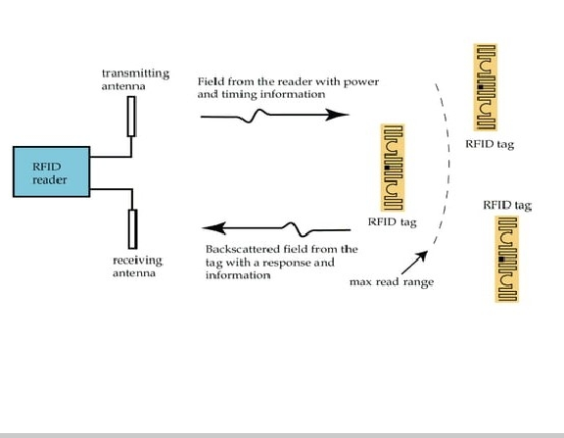

Fig.Working Principle of RFID System Operation

The RFID systems distinguish from each other by system usage, operating frequency, reading distance, protocol, power transfer to the tag, the procedure for sending data from the tag to the reader, and so on . The most general classification is so called “near-field” and “far-field” RFID, which is categorized by the method of power transfer between the reader and the tag. These two systems adopt different approaches, namely inductively/appreciatively coupling and electromagnetic (EM) wave capturing. The other classification is based on the method to power up the tags. The RFID systems can be classified as “passive”, “active”, and “semi-active” RFID. An active tag uses its on-board power supply (for instance battery) to support microchip operation and transmit data to a reader. In passive RFID systems, RFID tags do not have any on-board power source, and instead use the power emitted from the reader to energize itself and transmit its stored data back to the reader. In between, the tag in the semi-active RFID system uses an on-board power supply to energize the microchip but the power emitted from the reader to transmit its data back to the reader.

An RFID reader communicates with a tag through the reader antenna which broadcasts the RF signals from a reader transmitter to its surroundings and receives the response from the tags. Antenna is one of the key factors for RFID systems; the detection range and accuracy are directly dependent on the performance of reader /tag antennas. In addition, optimized antenna design will benefit the RFID system with longer reading range, better accuracy, reduced antenna fabrication cost, and simple system configuration and implementation.

Since the frequency available for RFID applications varies within a broad frequency range from LF (125–134.2 kHz), high frequency (HF) (13.56 MHz), ultra-high frequency (UHF) (840–960 MHz) to MWF (2.4 GHz, 5.8 GHz, and 24 GHz), the RFID antenna designs feature distinct requirements and variations. Therefore, some unique issues should be taken into account when designing RFID antennas:

Near-field Reader Antenna:

Loop antennas have been widely used in LF / HF RFID systems as reader antennas for many years since most of the LF / HF RFID systems are based on inductively coupling for reader / tag power transferring and communications. The main design considerations of these electrically small loop antennas include coupling zone size, magnetic field strength, quality factor, impedance matching, environment, and so on. When the operating frequencies rise to UHF band, the conventional solid-line loop antenna cannot operate properly since the perimeter of the loop antenna may be of several operating wavelengths for adequate coverage. The electrically large solid-line loop antenna cannot generate even magnetic field distribution in the near-field zone of the antenna because the current distribution along the loop experiences phase-inversion and current nulls, which degrades the reliability of RFID systems. The major challenge to design such UHF near-field RFID reader antennas is to ensure electrically large loop antennas producing the strong and uniform magnetic field distribution over a larger interrogation zone.

Far-field Reader Antenna:

Far-field RFID reader antennas have a number of variations wherein the most commonly used is the circularly polarized antenna for detecting arbitrarily oriented tags. Linear antennas such as dipole antennas have also been adopted in some specific applications where the orientation of the tags is fixed. Generally, the major considerations in far-field reader antennas include frequency range / bandwidth, polarization, gain, axial ratio, impedance matching, size, cost, and mechanical robustness. A broadband antenna which features desirable performance across the entire UHF RFID band of 840−960 MHz (13.3%) would be preferable for system configuration, implementation, and cost reduction

RFID Tag Antenna:

A typical passive RFID tag consists of an antenna and a microchip. The characteristics of the microchip are quantified by IC manufacturers and cannot be modified by users. The key challenge to design a tag antenna is conducted with a prior selected microchip under the various constraints to achieve a maximum reading range. Generally, the following issues should be addressed when designing a tag antenna:

1. Receiving maximum signals from a reader antenna to power up a microchip. The far-field tag antenna is required to be conjugate matched to the microchip. For near-field tag antenna (coil), proper inductance is required to configure a resonant circuit with chip capacitance at the operating frequency.
2. Small/thin enough for being attached to or embedded into the specified object.
3. Insensitive to the attached object to keep performance consistent.
4. Required radiation patterns (omnidirectional, directional or hemispherical).
5. Robust in mechanical structure.
6. Low cost in both materials and process.

In general, loop type antennas are most commonly used near-field RFID systems to capture the energy from the reader by magnetic field coupling. For far-field applications, various types of antennas such as dipole antenna, meander line antenna, slot antenna, and patch antenna are widely being employed.

**4.1.2 Proposed Antenna Design**

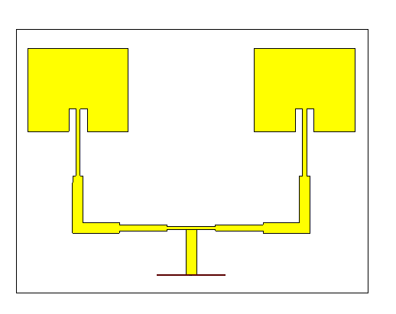

Fig.: Structural layout of 2\*1 Array Antenna

The antenna is designed for the operation that enable reading of an Item Level Tag which works with UHF RFID tags that incorporate an inductive near-field component with high performance, low cost antenna solution which can be mounted top or bottom of the table. The proposed methodology is depicted in the below flowchart, here the Microstrip patch array antenna is designed which operates at the resonating frequency of 2.5GHz.Inset feeding technique which is a type of line feeding technique is used in design. The design parameters like length, width and thickness of ground, substrate and antenna are formulated. The orientation, shape and feeding technique of an antenna is designed using CST tool. The designed micro strip patch antenna is then analyzed with respect to VSWR, return loss and other specification required.

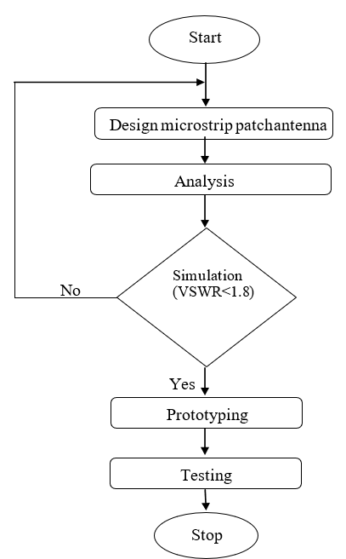

Fig. Flow chart of proposed antenna

Microstrip antennas are very flexible and are used in an array to synthesize a desired pattern which cannot be obtained with a single element. We use an array to extend the performance of the antenna, scan the radiation pattern beam of an antenna system, enhance the directivity and gain which would be better compared to that of a single element. The elements can be fed by single line or by multiple lines in a feed network arrangement. The important parameter for the design of a micro strip patch antenna is the Frequency of operation (fr). The resonant frequency of the antenna should be chosen appropriately. The resonant frequency chosen for the design is 2.5GHz. Hence the designed antenna must be competent to function in this frequency**.**

Our antenna was first configured as a single patch antenna, and after assessing the results for the antenna as S11 plot, input impedance, gain, directivity, and voltage standing wave ratio (VSWR), then we changed the antenna design to a 2\*1 linear antenna array to improve the results.

*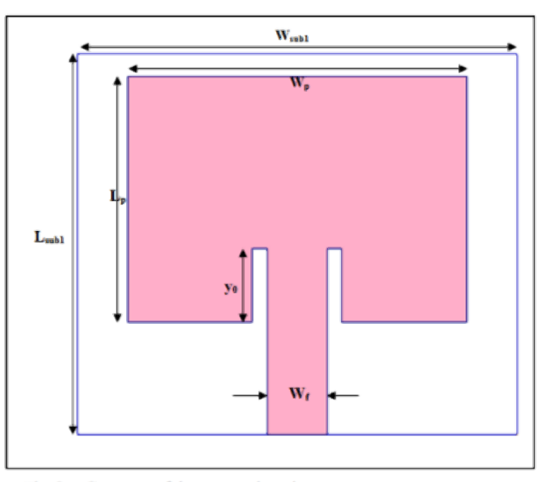*

Fig. Geometry of the proposed patch antenna.

A 50-microstrip line supplies the antenna. It is built on a substrate with a thickness of 1.6 mm.And the substrate of type RT/duroid 5880 which dielectric constant is 2.2 mm.The antenna is designed using CST tool and the results are analyzed.

Equations (1) and (2), respectively, yield the patch's dimensions, Wp and Lp, where ∆L is the length's extension (derived from equation (3)), Ɛreff is the effective permittivity by equation (4), equation (5) is used to calculate the width of the microstrip line, and equation(6) may be used to calculate slot length (Y0).

$Wp= \frac{C}{2*fr}* \sqrt{\frac{2}{εr+1}}$ (1)

$Lp= \frac{C}{2*fr\sqrt{εreff}}- 2* ∆L$ (2)

$∆L=0.412*h* \frac{\left(εreff+0.3\right)(\frac{Wp}{h}+0.264)}{\left(εreff-0.258\right)(\frac{p}{h}+0.813)}$ (3)

$εreff= \frac{εr+1}{2}+ \frac{εr-1}{2}*{\left[1+12*\frac{h}{Wp}\right]}^{\frac{-1}{2}}$ (4)

$Z0= \frac{60}{{εreff}^{\frac{1}{2}}} *ln\left[\frac{8h}{Wf}+ \frac{Wf}{4h}\right]$ (5)

$Y0= \frac{Lp}{{2*(εreff)}^{\frac{1}{2}}}$ (6)

Where Z0 is the microstrip line impedance, h is the substrate thickness, fr is the resonance frequency and C is the speed of light.

It is necessary designing an antenna with highly radiation performances (gain, directivity) to get the long distance communication requirements and the easy way to do it is increasing the radiating elements number. Hence,we kept the same specifications (Permittivity, type and thickness of substrate) and the same single patch antenna dimensions at the design frequency. This structure is composed by two identical elements and for exciting the proposed array antenna, we used a simple power divider.

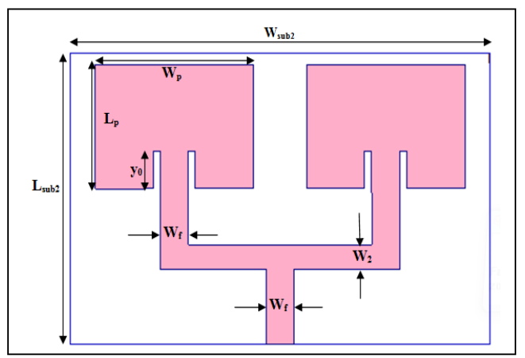

Fig. Geometry of the proposed linear array antenna 2x1.

The following table represents the patch antenna array dimensions:

|  |  |  |
| --- | --- | --- |
| **COMPONENTS** | **WIDTH** | **LENGTH** |
| **SUBSTRATE** | SW = 180 | SL = 130 |
| **PATCH** | PW = 47 | PL = 39.1 |
| **QUARTER – WAVE**  **TRANSFORMER (FEEDLINE)** | FW = 2.01 | FL = 20.7 |
| **GAP** | GW = 3.3 | GL = 10.7 |
| **INPUT\_PORT** | INW = 4.93 | INL = 21.93 |
| **T - JUNCTION** | TW = 1.43 | TL = 22.62 |
| **CONNECTOR** | CW = 2.888 | CL = 22.26 |
| **KONNECTOR** | KW = 4.93 | KL = 21.93 |

**TABLE: DIMENSION OF 2\*1 ARRAY STRUCTURE**

As an important component in RFID systems; reader and tag antenna design will affect the detection range and accuracy directly. There are many practical issues must be taken into account in antenna designs for specific RFID applications, in particular, the frequency range, interrogation zone, field distribution, gain, polarization, impedance

matching, quality factor, environment effect, size, cost, and so on. Recently, a near-field UHF RFID antenna has been increasingly required by systems in market which is designed to generate strong and uniform magnetic field strength. On the other hand, the wider and wider UHF frequency bands for RFID need the universal far-field UHF RFID antennas operating with higher gain as well as wider axial ratio beam width.

Besides its low cost nature, the proposed design has reconfigurable beam shapes and polarization features, opening doors to different tracking needs such as beam tilt in one direction for eliminating stray tag detection, grating lobes for doorway tracking applications, and so on. The antenna is scalable to suit custom requirement if needed. The suggested manufacturing process to maintain the cost efficacy is by using a decal foil for patch antennas and microstrip line feed network. The decal can be obtained by stamping antenna, feed network patterns and ground plane. This antenna array design shall be considered as smart antenna when combined with software development that can track directions by changing the beam shapes, or changing polarization in environments that require high isolation between wanted and unwanted tags. This design will be very useful for inventory tracking in industries and retail.

**4.1.3 Results and Discussions**

In this part, we present a comparative study between a simple patch antenna and a 2\*1 array patch antenna by using the simulator: CST microwave studio. The simulator is well known for its high-performance 3D EM analysis software package for designing, analyzing and optimizing electromagnetic (EM) components and systems.

The simulation has been accomplished to reach the wanted results in terms of S11, VSWR, Zin(input impedance), gain and directivity at the resonance frequency (2.5 GHz).

**4.1.3.1 RETURN LOSS/S11 vs FREQUENCY**

An antenna's Return Loss is a figure that indicates the proportion of radio waves arriving at the antenna input that are rejected as a ratio against those that are accepted.

It is specified in decibels (dB).Return loss is always positive while S11, in dB, is always negative. While the two terms are related as S11[dB] = -RL, they are not the same, and their behaviors are opposite.

Return Loss (RL)/S11 is the important specification of interest for an antenna design that indicates the proportion of radio waves arriving at the antenna input that are rejected as a ratio against those that are accepted.

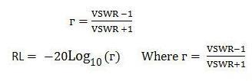

Here,the term ‘Γ’ denotes reflection coefficient.The reflection coefficient is the ratio of the amplitude of the reflected wave to the amplitude of the incident wave, with each expressed as phasors, and the symbol of this coefficient is Γ (capital gamma).

Basically the return loss should be less than -10dB, which is shown in the figure below. The measured return loss at 2.5 GHz for the suggested antenna is -24.23 dB.The following equation can be evaluated to obtain the return loss parameter:

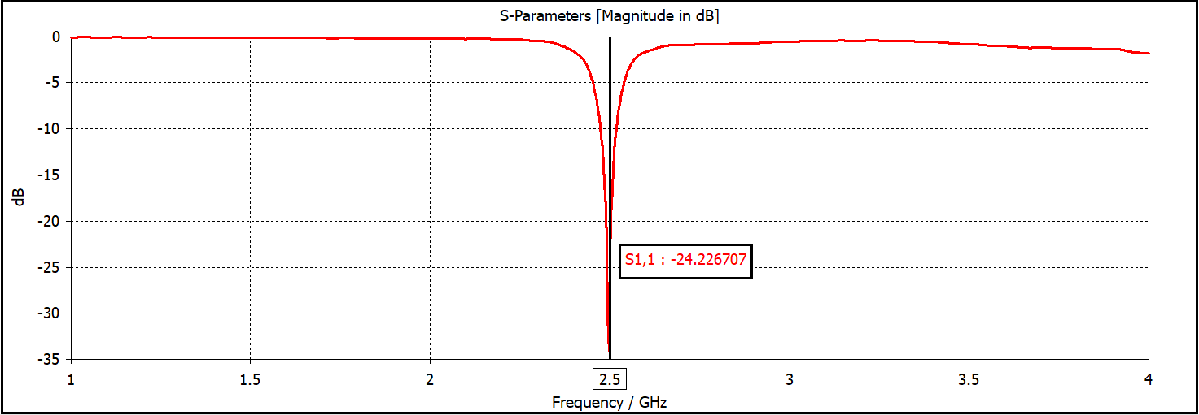

Fig : Return loss of the proposed Antenna array

**4.1.3.2 VSWR vs FREQUENCY**

VSWR (Voltage Standing Wave Ratio) is a measure of how efficiently radio-frequency power is transmitted from a power source, through a transmission line, into a load (for example, from a power amplifier through a transmission line, to an antenna).

Voltage Standing Wave Ratio is very important parameter, which is used to measure how well the antenna impedance is matched to the transmission line. The lower the VSWR is better the antenna is matched and large amount of power is delivered. The VSWR values vary from one to infinite, but VSWR value below 2 in practical implementation is acceptable for the best antenna based applications.

The antenna adaptation quality is defined either by its input impedance or its VSWR which must be less than 2, at the resonance frequency, for the antenna to be well adapted.The VSWR for the proposed antenna was measured at 2.5 GHz resonance frequency and is 1.13.

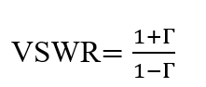

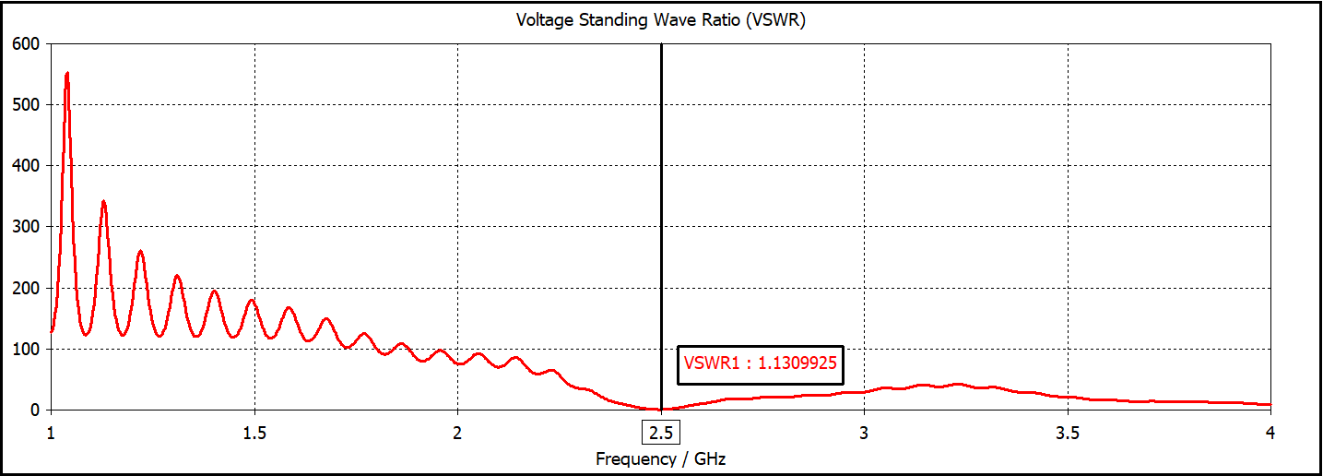

Fig.VSWR of the proposed Antenna array

**4.1.3.3 GAIN vs FREQUENCY**

Antenna gain is the ability of the antenna to radiate more in the desired direction and radiate less in undesired direction . If an antenna could be made as a perfect sphere, it would radiate equally in all directions. It is the product of directivity and efficiency.

The gain is the graphical representation of the directivity of the proposed antenna and is represented in dB.The following table presents the advantages of our proposed array antenna comparing to others in the literature. It can be seen that our proposed array antenna is miniaturized and represents a significant gain and a good adaptation.

|  |  |  |
| --- | --- | --- |
| PARAMETERS | GAIN | RETURN LOSS |
| PROPOSED ANTENNA | 9.87 | -24.23 |
| REFERENCE I. | 6.51 | -31.42 |
| REFERENCE J | 5.05 | -------- |

TABLE. Results comparison between other research papers and ours.

The measured Gain is 9.87 dB for the suggested antenna at the resonance frequency of 2.5 GHz.

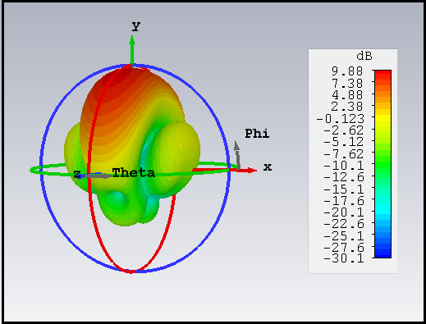

Fig. Gain of the proposed Antenna array

**4.1.3.4 DIRECTIVITY vs FREQUENCY**

Directivity is the measure of the concentration of an antennas's radiation pattern in a particular direction. Directivity is expressed in dB.The higher the directivity, the more concentrated or focused is the beam radiated by an antenna.

It is one of the most important parameter and the measured Directivity is 10.45 dB for the suggested antenna at the resonance frequency of 2.5 GHz.

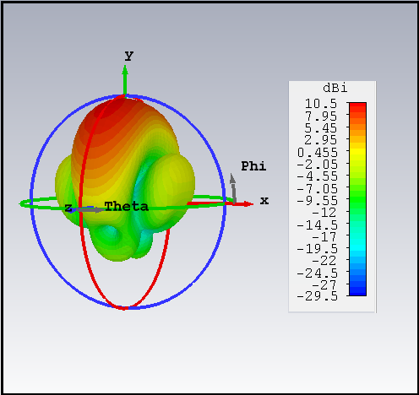

Fig. Directivity of the proposed Antenna array

**4.1.3.5 INPUT IMPEDANCE vs FREQUENCY**

The input impedance of [antenna](https://electronicsdesk.com/antenna.html) is basically the impedance offered by the antenna at its terminals. It is defined as the ratio of voltage to the current across the two input terminals of the antenna. Generally, the antenna impedance is given as:

IMG_256

It is one of the most important parameter and for the proposed antenna array, Zin = (52.85-j4.76) is the measured value of input impedance at the frequency of 2.5 GHz.

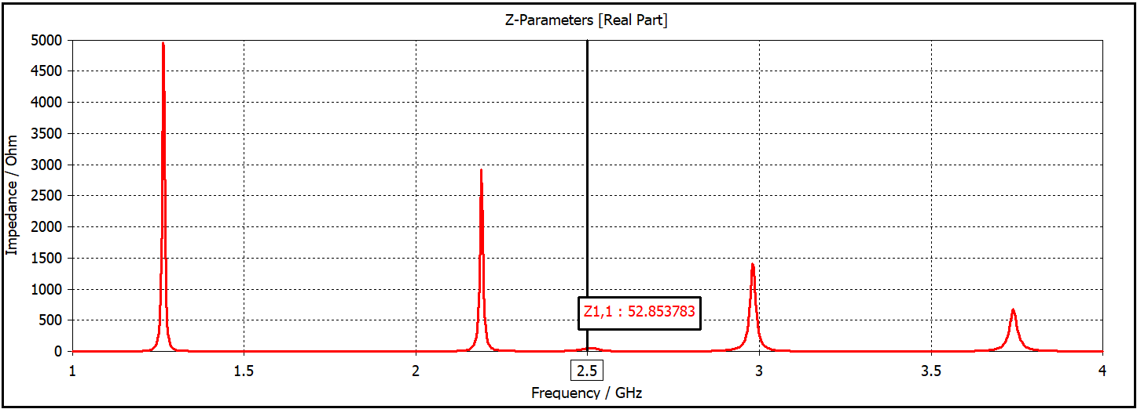

Fig.: Input impedance of proposed Antenna array

**4.1.3.6 RADIATION PATTERN**

Radiation pattern is the property of antenna at space domain.It is the graphical representation of radiation properties of antenna.The patch's radiation at the fringing fields results in a certain far field radiation pattern. This radiation pattern shows that the antenna radiates more power in a certain direction than another direction. The antenna is said to have certain directivity. This is commonly expressed in dB.

The energy radiated by an antenna is represented by the Radiation pattern of the antenna. The main lobe is the direction of maximum radiation and the side lobe is the direction of undesired direction.These are the areas where the power is wasted.The direction of the main lobe indicates the directivity of the antenna.There is another lobe that exist in opposite to the main lobe,known as back lobe. A considerable amount of energy is wasted even here.

The array antenna produces the radiation’s center with more intensity or focus.The radiation pattern is a characteristic which helps to comprehend the designed antennas behavior.

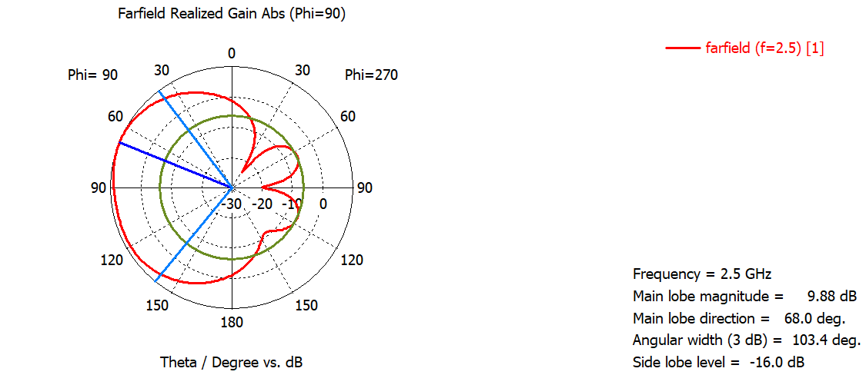

Fig. 2D Radiation pattern of proposed Antenna array

**CHAPTER 5**

**5.1 CONCLUSIONS**

The main focus of this research is the construction of a microstrip patch antenna with a 2\*1 array and a working frequency of 2.5 GHz using CST Microwave Studio. In comparison to a single patch antenna, the 2\*1 array antenna offers better radiation parameter performances. With a gain of 9.87 dB, VSWR of 1.13, good performance on the S11 plot with a value of -24.23 dB, and a directed radiation pattern, it stands out for its great adaptability.From obtained results, gain and directivity were improved when we passed to a 2\*1 array antennas. It is clear that increasing the number of patches is a solution to further improve radiation performances and obtain a more directive beam.

The antenna that was developed can be made capable to withstand the requisites of RFID system applications.As an important component in RFID systems; reader and tag antenna design will affect the detection range and accuracy directly. There are many practical issues must be taken into account in antenna designs for specific RFID

applications, in particular, the frequency range, interrogation zone, field distribution, gain, polarization, impedance matching, quality factor, environment effect, size, cost, and so on.

So on concluding all the aspects of the research,the major goal of this project is to develop an array antenna which reads microwave band that will be included into a noting system to recognise moving objects or live beings. In order to build this array antenna, performance requirements in terms of frequency, flexibility, gain, and directivity must be taken into consideration.

**5.2 FUTURE SCOPE**

* Hence it has been justified that the increase in antenna element results in more improved working performance of the proposed antenna.So,further work can be done on increasing array configuration from 2\*1 to 4\*1 array configuration of the microstrip patch antenna.
* The position of patches in array antennas must be carefully chosen to avoid mutual coupling. Methods to minimize mutual coupling will be exploited in a future work.
* Antenna size can be further reduced as the length of the antenna is inversely proportional to the frequency and directly proportional to the wavelength. The higher the frequency and the shorter the wavelength, the shorter the antenna can be made.
* In future other different type of feed techniques can be used to calculate the overall performance of the antenna without missing the optimized parameters in action.
* The same design method is used at different dielectric material of low loss tangent specially to enhance radiation efficiency and gain.
* Future work can be focused on the analysis and design of antennas for advanced technologies like, wide band and cognitive radio.

**APPENDICES**

**APPENDIX A. Standards for RFID Tags**

The RFID industry has multiple standards and an established class system. The industry also subdivides standards according to interface protocol, data content, conformance, and applications. The Electronic Product Code (EPC) standard specifies longevity and memory requirements Memory requirements include:

* 96-bit EPC/number.
* 32- to 64-bit tag identifier.
* 32-bit kill password.
* 32-bit access password.
* Manufacturer-dependent user memory as high as 64 KB.

The concept of a kill password and access password may be confusing. The protocol does not provide for a mechanism to prevent the reading of a Gen2 tag but has the ability to lock information using an access password and to render a tag inoperable using a kill password. A kill password will either render the tag unreadable or change the state of the tag–for example, changing the state of a retail tag from “inventory” to “purchased.”

The International Organization for Standardization (ISO) has created multiple standards for tracking cattle, air interface protocols, payment systems, vicinity cards, and performance testing.

The Auto-ID Center developed the EPC and related technologies using UHF RFID. The Auto-ID Center desired a global RFID system based on an open standard due to the inherent need for the ability to track goods from one country to the next. The center developed a numbering system and network infrastructure using ISO air interface protocols but, instead of using the ISO UHF protocol, developed its own due to the complexity of the existing ISO protocol. The Auto-ID protocol, with some procedures now accepted as an ISO standard (Gen2), originally proposed six classes of UHF RFID tags:

* **Class 0**–a read-only passive tag with non-programmable memory.
* **Class 1**–a write-once, read-many passive tag.
* **Class 2**–a read-write passive tag with up to 65 KB of read-write memory.
* **Class 3**–a semi-passive tag with up to 65 KB read-write memory; a Class 2 tag with a built-in battery to support increased read range.
* **Class 4**–an active tag that uses a built-in battery to run the microchip's circuitry and to power a transmitter that broadcasts a signal to a reader.
* **Class 5**–an active RFID tag that can communicate with other Class 5 tags and/or other hardware.(1)

The industry adopted the EPC Radio Frequency Identity Protocols Generation-2 UHF RFID standard in 2004. This standard specifies the requirements for all classes of Gen2, which are backward compatible with first-generation tag standards. The 2004 standard applies to all tag classes but particularly to Class 2 tags. The EPC standard specifies longevity and memory requirements.The Four EPC identifiers described in the standard are shown in Table A-1.

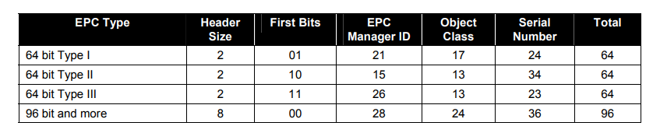Table A-1. EPC Identifier Formats

**REFERENCE DATA**

* Violino, B. A Summary of RFID Standards *RFID Journal,*January 16, 2005 <http://www.rfidjournal.com/articles/view?1335>.
* Fujitsu Limited Datasheet: World's Largest-Capacity 64KByte FRAM Metal Mount RFID Tag 2014 <http://www.fujitsu.com/jp/group/frontech/documents/en/solutions/business-technology/intelligent-society/rfid/ait64k/brochure-ait64k.pdf>.
* SkyRFID,Inc RFID Gen 2–What Is It?–Smart RFID <http://skyrfid.com/RFID_Gen_2_What_is_it.php>.
* U.S. Department of Defense. *United States Department of Defense* *Suppliers' Passive RFID Information Guide.* Version 15.0, January 2010. <http://www.acq.osd.mil/log/sci/.AIT.cfml/DoD_Suppliers_Passive_RFID_Info_Guide_v15update.pdf>.

**APPENDIX B. RFID SYSTEM OPERATING FREQUENCY COMPARISON**

**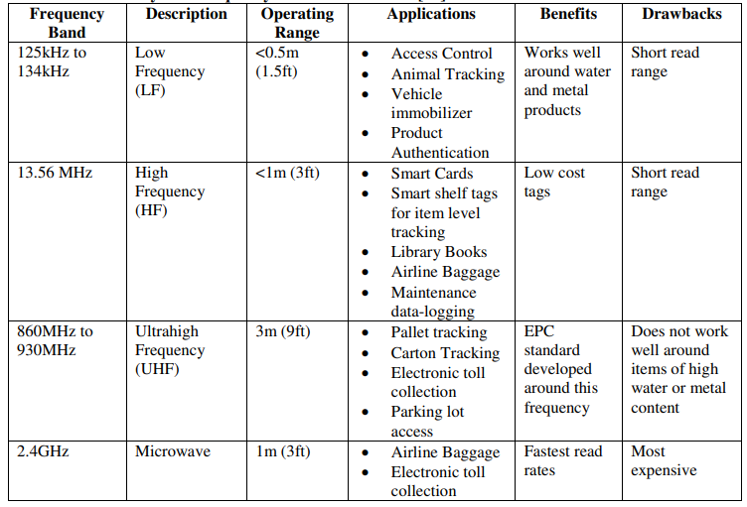**

Table B1: RFID System Frequency Band Classification.

**APPENDIX C. MATLAB CODES**

**Code C1: 2D Radiation Pattern Generator**

clc; n=input('Enter step size');

q=1;

for i=0:n:360

x(q)= input(‘Enter power in micro volts’);

if (x(q)<=0)

x(q)=1;

end

v(q)=20\*log10(x(q));

t(q)=i\*pi/180;

q=q+1;

end

v(length(v))=v(1);

figure(1)

polar(t,v,’red’);

**Code C2: Patch Antenna Dimensions Calculator**

function Antcal()

%This function is to be used to calculate the different parameters of a rectangular patch antenna

clc;

fo=input('Enter frequency of operation (fo) in Hz');

Er=input('Enter Dielectric constant (Er)');

h=input('Enter height of substrate (h) in m'); W=(3\*10^8)/(2\*fo\*sqrt((Er+1)/2))

Eref=(Er+1)/2+((Er-1)/2)/(sqrt(1+12\*h/W))

Lef=(3\*10^8)/(2\*fo\*sqrt(Eref))

dL=((0.412\*h)\*(Eref+0.3)\*(W/h+0.264))/((Eref-0.258)\*(W/h+0.8))

L=Lef-2\*dL

Lg=6\*h+L

Wg=6\*h+W

end

**REFERENCES**

1. C. A. Balanis, *Antenna theory: Analysis and Design* (3rd edition, John Wiley & Sons, 2013).
2. J. R. James, P. S. Hall and C. Wood, *Microstrip Antenna Theory and Design* (IET, 1981).
3. Kai Da Xu, Han Xu, Yanhui iu, Jianxing Li and Qing Huo Liu, *Microstrip Patch Antennas with Multiple Parasitic Patches and Shorting Vias For Bandwidth Enhacement* (IEEE Access, Volume: 6, P. 11624 – 11633, 2018).
4. Eduardo S. Silveira, Denial C. Nascimento, Alexis F. Tinnoco and Marcus V.P. Pina, *Design of Microstrip Antenna Array with Suppressed Back Lobe*, (Journal of Microwaves, Optoelectronics and Electromagnetic Applications, Vol. 16, No. 2, pp. 460-470, 2017).
5. Nusrat Jahan Shimu, Anis Ahmed, *Design and Performance Analysis of Rectangular Microstrip Patch Antenna at 2.45 GHz* (2016 5th International Conference on Informatics, Electronics and Vision (ICIEV), IEEE).
6. Giang Bach Hoang, Giap Nguyen Van, Linh Ta Phuong, Tuan Anh Vu and Duong Bach Gia, *Research, Design and Fabrication of 2.45 GHz Microstrip Patch Antenna Arrays for Close-Range Wireless Power Transmission Systems* (2016 International Conference on Advanced Technologies for Communications (ATC), IEEE).
7. Hafid TIZIYI, Fatima RIOUCH, Abdelwahed TRIBAK, Abdellah NAJID, *Compact Dual-band Microstrip Antenna for Handheld RFID Reader* (IEEE 2015).
8. A. ELHamraoui, E. Abdelmounim, J. Zbitou, A. Tajmouati, L. EL Abdellaoui, A. Errkik, M. Latrach, *Compact CPW-Fes Dual-Band Uniplanar Antenna for RFID Applications* (2015, IEEE).
9. Bhushan Bhimrao Dhengale and Deepak C. Karia,” A 5.8 GHz ISM band microstrip antenna for RFID application” International Conference on Nascent Technologies in the Engineering Field (ICNTE-2015) pp.1- 4, Jan.2015.
10. Veeramani. A, Vijayakrishnan. J, Afsane Saee Arezomand, Ferdos B. Zarrabi, “ Compact S-shaped EBG Structures for Reduction of mutual coupling”, International Conference on Advanced Computing & Communication Technologies, 2015.
11. [ttps://www.chst.com/](https://www.cst.com/)

**LIST OF PUBLICATIONS**

**Chirag Rastogi, Chandan Kumar, Anishay Kumar, Tushar Sirohi, Design and Simulation of Microstrip Patch Antenna Array for RFID System, (Electronics and communication Department, Noida Institute of Engineering and Technology, Greater Noida, India, International Conference on Emerging Technologies and Innovations (EmergIN-2023)).**

**CERTIFICATE**

****